LAB 6.4
NAME: KRISHNA VAMSHI
ENROLLMENT NO: 2403A52383
TASK 1: Start a Python class named Student with attributes name, roll_number, and marks. Prompt GitHub Copilot to complete methods for displaying details and checking if marks are above average.
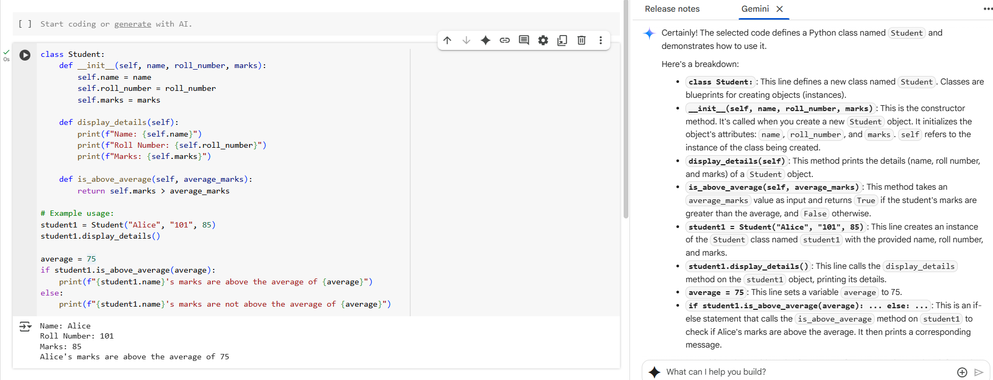
TASK 2: first two lines of a for loop to iterate through a list of numbers. Use a comment prompt to let Copilot suggest how to calculate and print the square of even numbers only.
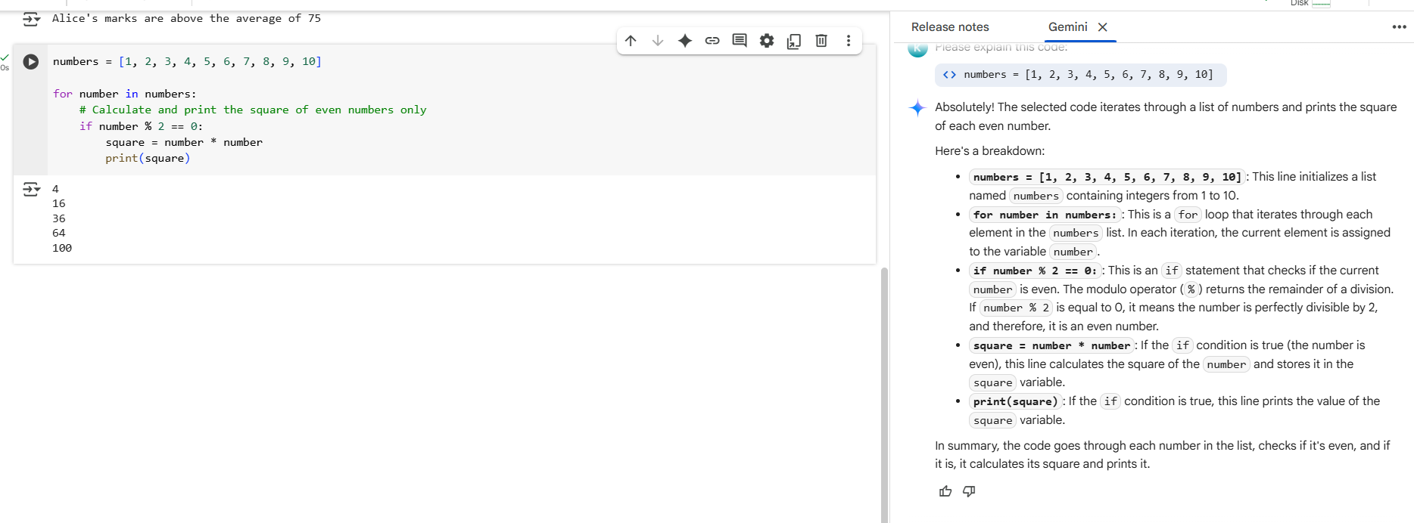
TASK 3: Create a class called BankAccount with attributes account_holder and balance,methods for deposit(), withdraw(), and check for insufficient. Balance
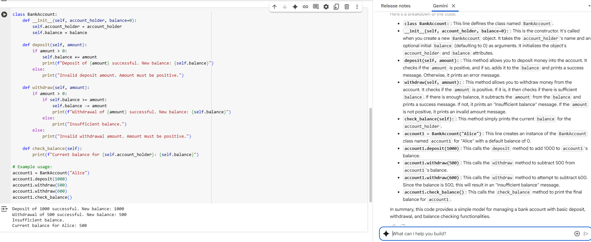
TASK 4: Define a list of student dictionaries with keys name and score. Ask Copilot to write a while loop to print the names of students who scored more than 75.
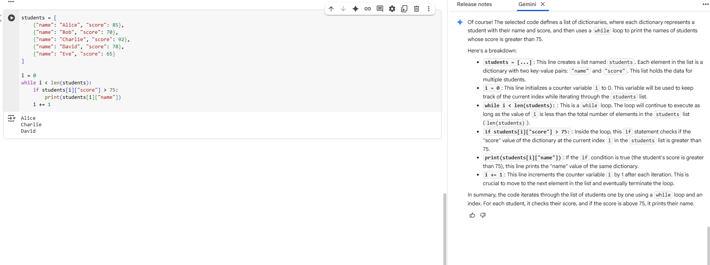

TASK 5: Begin writing a class ShoppingCart with an empty items list. Prompt Copilot to generate methods to add_item, remove_item, and use a loop to calculate the total bill using conditional discounts.
